|  |  |
| --- | --- |
|  |  |
|  |  |

|  |
| --- |
| Adaptive Vehicle  Lighting Control |
| For Smarter Vehicle |
|  |
| KPIT Technologies Ltd. |



“Connecting cars with technology for a smarter, better, and safer world.”

Project By:

Sakshi Kondekar

214862

**Project Vision**

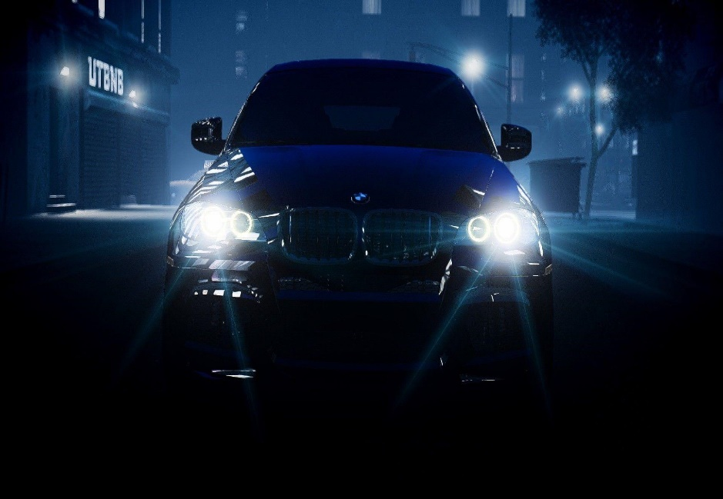

Table of Contents:

1. State of the Art-------------------------------------------------------4

1. Introduction ------------------------------------------------------4

2. 4W1H: --------------------------------------------------------------5

5. SWOT Analysis: ---------------------------------------------------7

6. Applications -------------------------------------------------------8

B. Stakeholder’s Requirements: ---------------------------------------9

1. MATLAB Modeling and Simulation: -----------------------------10
2. Working Methodology----------------------------------------------17
3. MATLAB and Simulink skills implemented: --------------------21
4. Test plan for testing the features standalone: ----------------26
5. References--------------------------------------------------------------28

# State of the Art

# Introduction:

Now days the no. of vehicle on road is increasing drastically and no. of accidents on road also increases. Especially at night most of the accidents are occurred due to dazzling of vehicle lights. Therefore, adaptive vehicle lighting system becomes more and more popular today. Not only in combustion engine vehicles, but also in some of those new model electric vehicles. Adaptive lighting system is a system which automatically controls the fog light, tail light and headlight of the car as per requirement for better utilization of lights and increasing the safety by reducing the human control.

The headlight during the night travel plays a major role. While driving there may be an irritating situation due to the headlight lamp focus from the opposite vehicle. It leads to accidents. In current practice, to control headlight beam manually by using switch this is place on the steering column. Use of manual dipper control is not done by most of the drivers due to many reasons because the operation of dipper control switch is hundreds of times at night driving. Other reason is the driver wants to pay more attention to the steering control instead of to dipper the head light beam. Thus, proposed system provides the driver better visualization of road and obstacles to drive safely by automatically controlling the direction and intensity of each light.

Adaptive headlights are an active safety feature designed to make driving at night or in low-light conditions safer by increasing visibility around curves and over hills. When driving around a bend in the road, standard headlights continue to shine straight ahead, illuminating the side of the road and leaving the road ahead of you in the dark. Adaptive headlights, on the other hand, turn their beams according to your steering input so that the vehicle’s actual path is lit up.

Similarly, when a vehicle with standard headlights crests a hill, the headlight beams temporarily point upwards towards the sky. This makes it difficult for drivers to see the road ahead and for oncoming motorists to see the driver approaching. In contrast, adaptive headlights use a self-levelling system turns the light beam towards required direction, according to the position of the vehicle.

A car’s fog lights are intended to help it be seen in conditions when visibility is less than 100m. Fog lights don’t help you see further up the road in fog. Fog lights are usually operated by a separate switch from the main light controls. Some cars use buttons to activate them - one for the rear, one for the front (where front fog lights are fitted) - while others feature a collar on the light stalk that you turn back and forth to turn them on. Some cars use the rotary light switch control to activate them - simply pull the switch towards you, and the fog lights will come on. Fog lights are designed to be used when visibility is severely restricted, chiefly by fog, but also in other poor visibility conditions such as snow or heavy rain. They should only be used when your car's main lights won't be enough to make you visible to other road users.

Tail lights are red lights on the back of a vehicle. They are turned on whenever the head lights are on. When stopping, the tail lights have a bright red appearance compared to a dimmer red appearance when the vehicle is in motion.

Adaptive headlights are still a relatively new safety technology, so there is limited data about their effectiveness. However, the Insurance Institute for Highway Safety (IIHS) in the United States has defined crashes where adaptive headlights would be relevant as all night-time front-to-rear collisions, single-driver, and same-direction side-swipe collisions. The IIHS also limited the group of relevant crashes to those that occurred while the driver was negotiating a curve. Given this, the IIHS estimates that adaptive headlights could have helped in 143,000 crashes in the United States in 2008, including 31,000 that resulted in injury and 2,553 that were fatal (IIHS 2008).

# 4W1H:

### What is adaptive vehicle lighting control system ?

Adaptive vehicle lighting control system uses electronic sensors to detect the speed of the car, how far the driver has turned the steering wheel, foggy and rainy weather, distance of car from any other cars travelling in the opposite direction, presence of light intensity outside. Proposed system uses these sensors data to automatically turn on or off the fog light, tail light as well as headlight. It controls the high beam and low beam operations of headlight depending on the street light present, distance of cars travelling in opposite direction and forward light. Also, it controls the direction of headlight depending on the steering position. The lights turn their beams around each bend in the road, giving a better view of what's ahead. Depending on difference situation and requirements system controls the intensity of each light.

### Where it can be used ?

Adaptive vehicle lighting system can be used in car where required sensors can be implemented and control lights automatically. System is most suitable for automatic cars as they are designed to reduce the driver’s control and intended to make features automatic.

### How it works?

System can be implemented by connecting various required sensors in car. When auto mode is selected for controlling light sensors data is used for controlling all lights of car. LDR is connected to detect the darkness. Sensor detects the position of the steering which turns the headlight of car in left or right direction by specified angle. Also, system takes the sensor data for street light present, distance of other vehicles travelling in opposite direction, any human or animal on road or obstacle, forward light to decide the switching of high beam and low beam of the headlight. Humidity sensors detects the intensity of fog present in air and according to the input system actuates the fog light with 30%, 60% or 100% intensity. When auto mode is on and there is darkness system turns on the tail lights.

### Why is it implemented ?

Standard headlights shine straight ahead, no matter what direction the car is moving. When going around curves, they illuminate the side of the road more than the road itself. Adaptive headlights react to the steering, speed and elevation of the car and automatically adjust to illuminate the road ahead. When the car turns right, the headlights angle to the right. Turn the car left, the headlights angle to the left. This is important not only for the driver of the car with adaptive headlights, but for other drivers on the road as well. Headlight intensity of vehicles poses a great danger during night travel. The drivers of most vehicles use high bright beam while driving at night. The glare of oncoming headlights can cause serious visibility problems. This causes inconvenience for the person travelling from the opposite direction. To avoid such incidents system is implemented to switch the high beam and low beam appropriately.

Fog usually increases the chances of accidents. So whenever driving in fog to reduce hazards, fog lights must be used. Tail lights are useful for indicating the vehicles or people on the road presence of the moving car. As each car lights plays an essential role in driving and indications for safety, using these lights appropriately is very important for safety of driver and others. As system controls all lights automatically, it reduces the efforts of driver as well as probability of accidents. It ensures the safety driving with improved driving experience.

### When does adaptive lighting control system come into play?

When car engine is on, Auto control mode is selected and darkness is detected by LDR system activates to control lights automatically

# SWOT Analysis

|  |  |
| --- | --- |
| Strengths:   * Prevent injuries and property damage due to accidents * Save driver’s time. * Driver don’t change the lights frequently manually to focus on steering more, which results in improper lighting for driving. This challenge is overcome by this adaptive lighting system. * While driving there may be an irritating situation due to the headlight lamp focus from the opposite vehicle which is reduced by controlling intensity of light automatically. * System is unaffected by most weather conditions * Cost effective | Weaknesses:   * In extreme conditions, heavy dirt and grime on the ultrasonic sensors reduce their effectiveness but can be easily remedied by wiping clean the sensors * System will work only when auto mode is turned on |
| Opportunities:   * For simplicity, it is assumed that the pitch of the vehicle remains horizontal and velocity of vehicle remains constant. System can be modified to work beyond this assumption. * Auto leveling of adaptive headlight can be done by using yaw sensor * Automatic Brake light, in cabin lights feature can be added. | Threats:   * Very heavy rain or snowfall can cause the ultrasonic sensor to indicate that an object appears closer than it really is. * Humidity sensor can detect false humidity even if few water droplets drops on sensor surface. |

# Applications

* This system can be used in any vehicle for controlling different lights stated.
* Subsystems can be modified to control the lights in home or industry

# Stakeholder’s Requirements

|  |  |  |
| --- | --- | --- |
| Feature | Stakeholder’s  Requirement | System Requirement |
| 1. Automatic headlight control | Headlight should adjust its direction, intensity. High beam and low beam of headlight must switch on or off as per operating conditions | Distance sensor  Light sensor  Controller  Steering position sensor  DC Motor |
| 1. Automatic Fog light control | When fog is detected while driving fog light must turn on with required intensity for clear vision | Humidity sensor  Controller |
| 1. Tail light control | When there is darkness tail light must be on | LDR sensor  Controller |

# C. MATLAB Modeling and Simulation:

1. Subsystems:

a. Auto/Manual Control Mode:

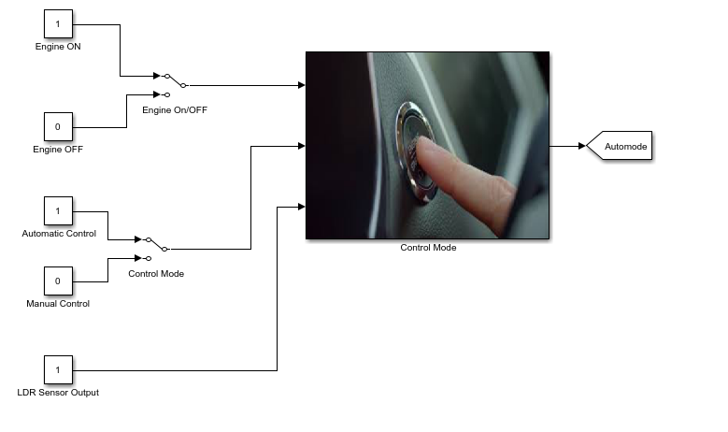

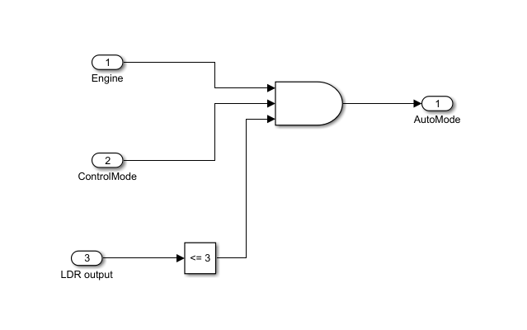

Fig. MATLAB model

b. Integrated ECU control unit:

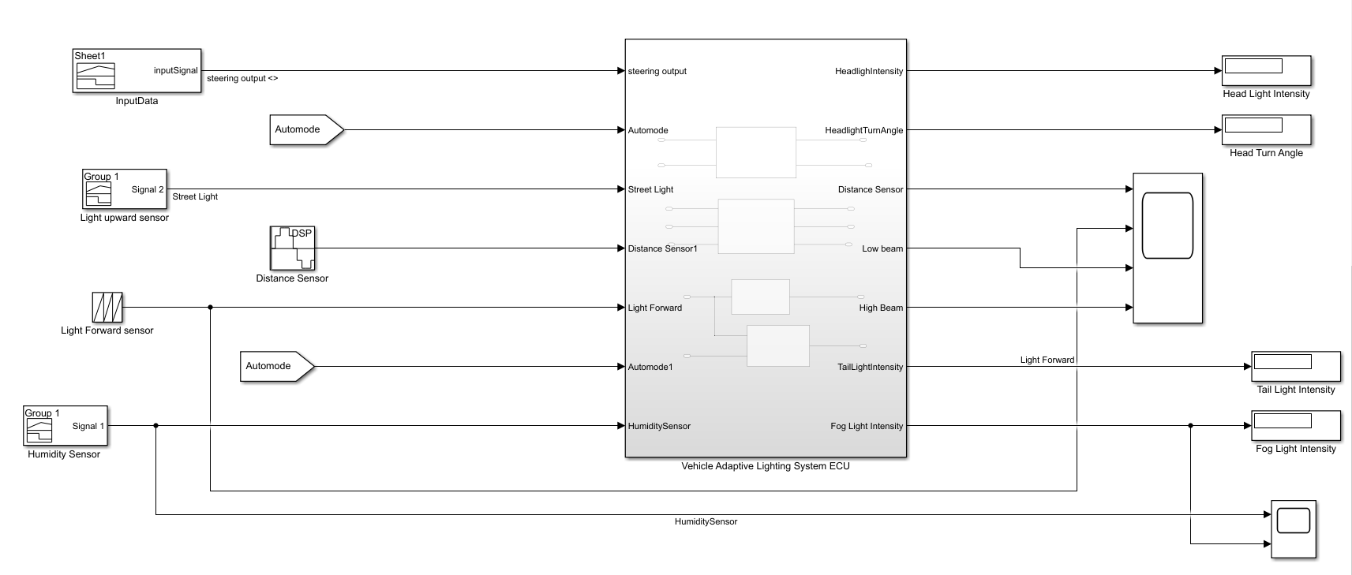

c. Headlight direction control system

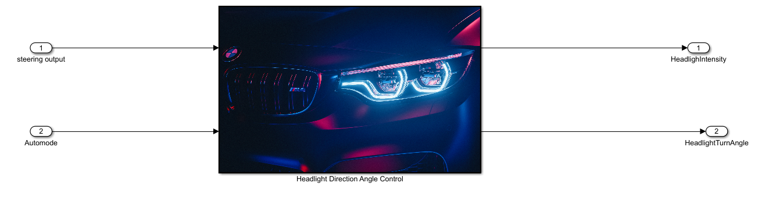

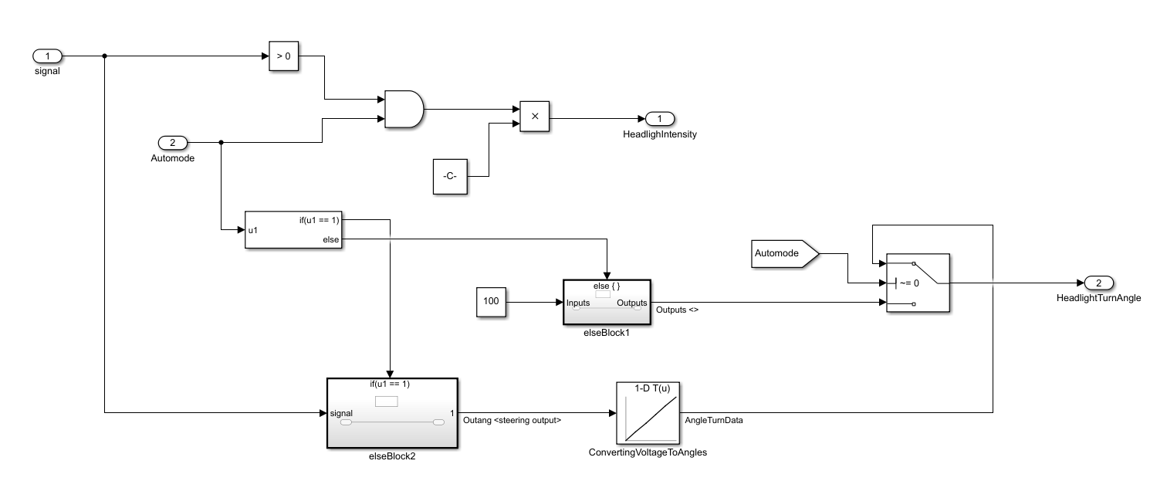

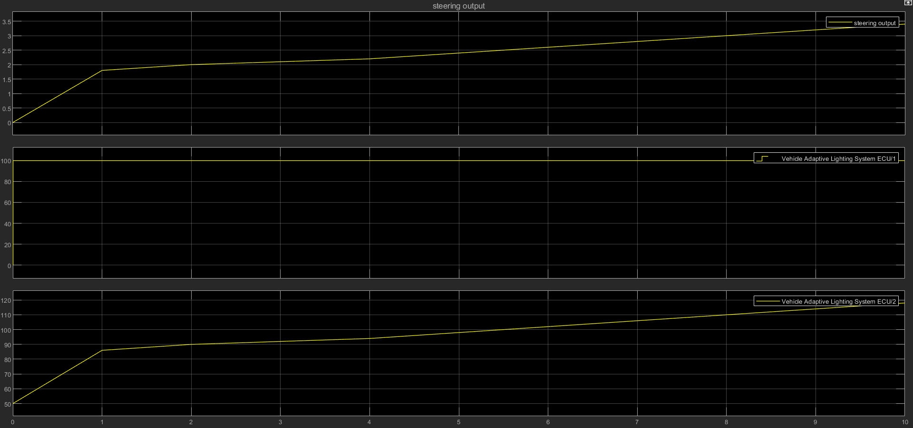

## d. Adaptive headlight beam control

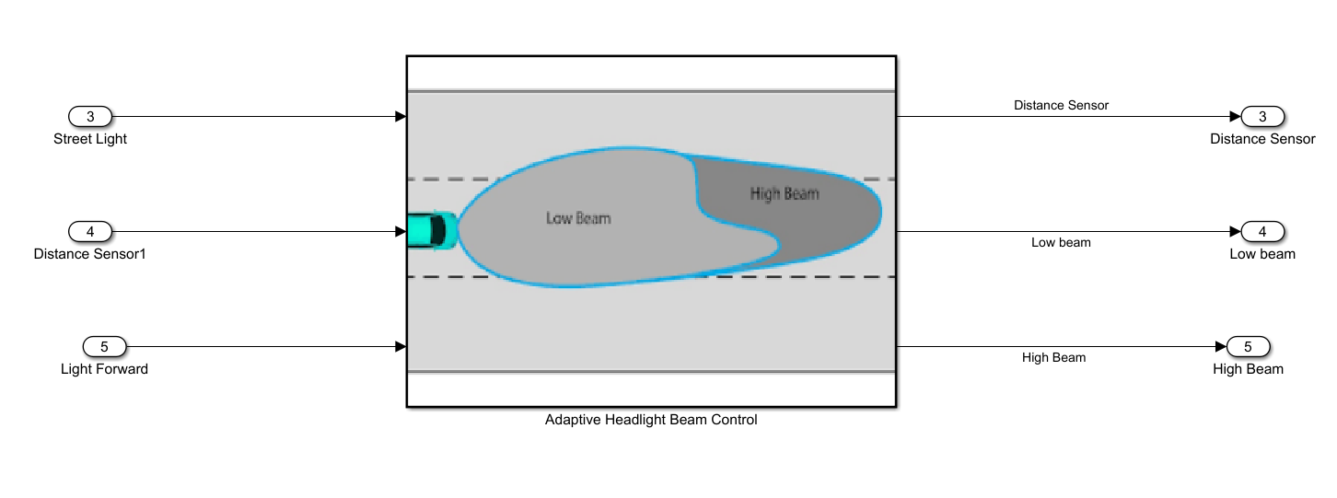

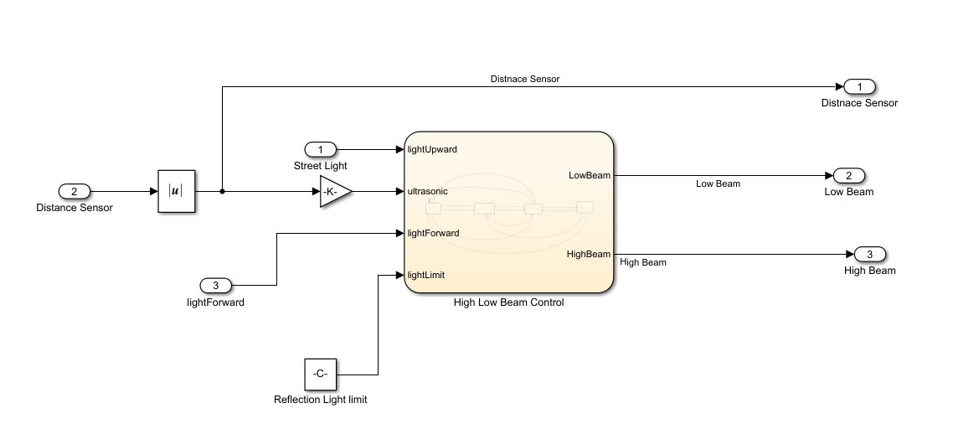

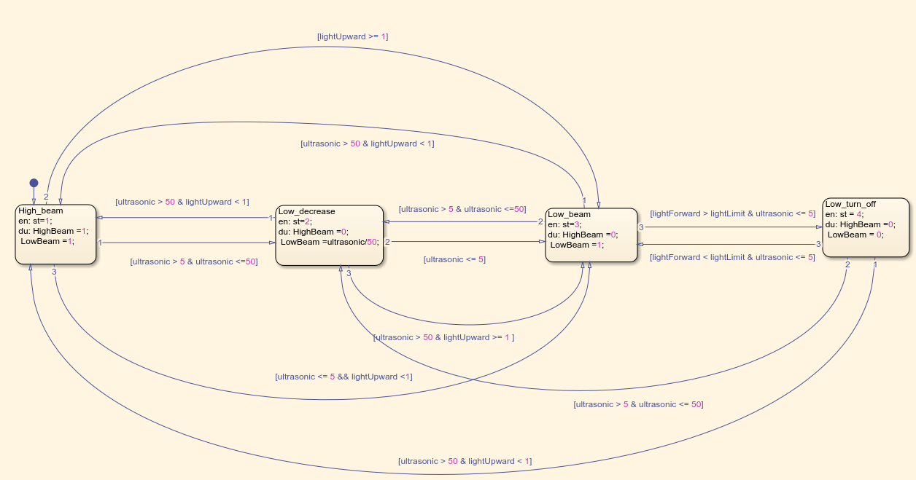

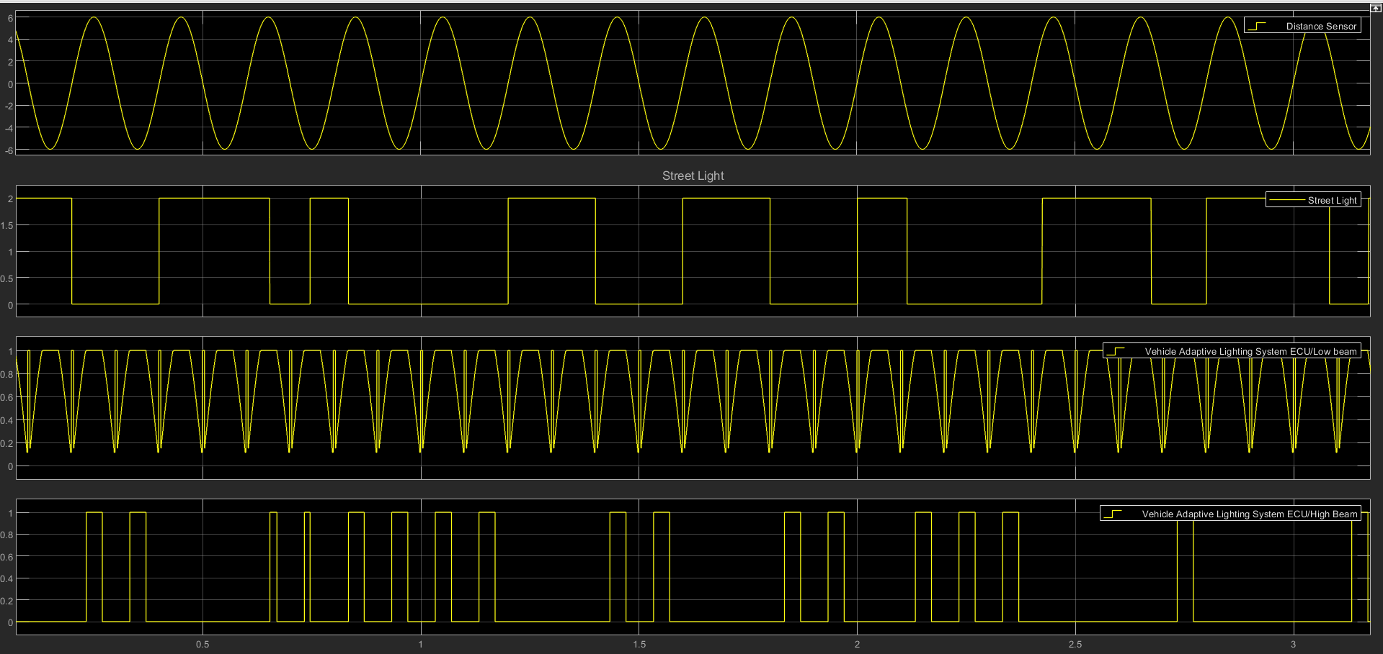

## e. Fog light and tail light control

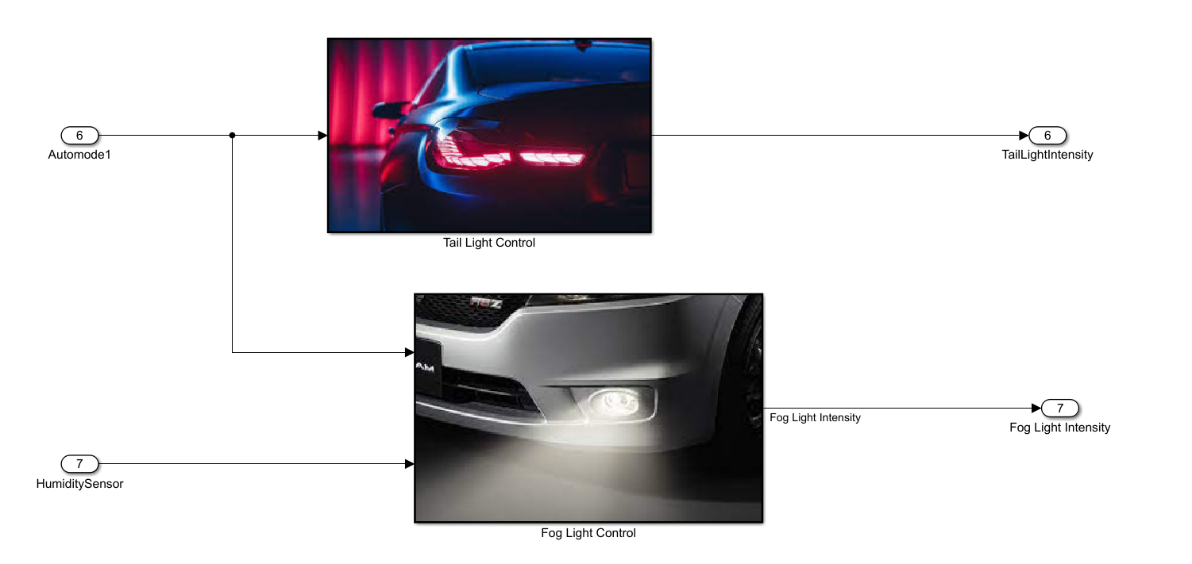

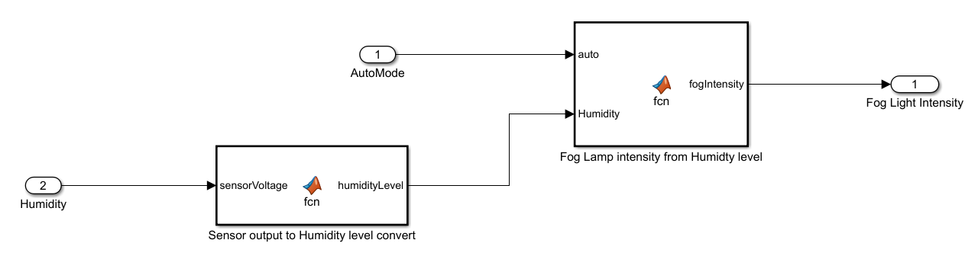

Fig. Fog light MATLAB model

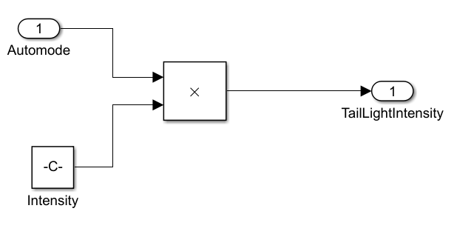

Fig. Tail light MATLAB model

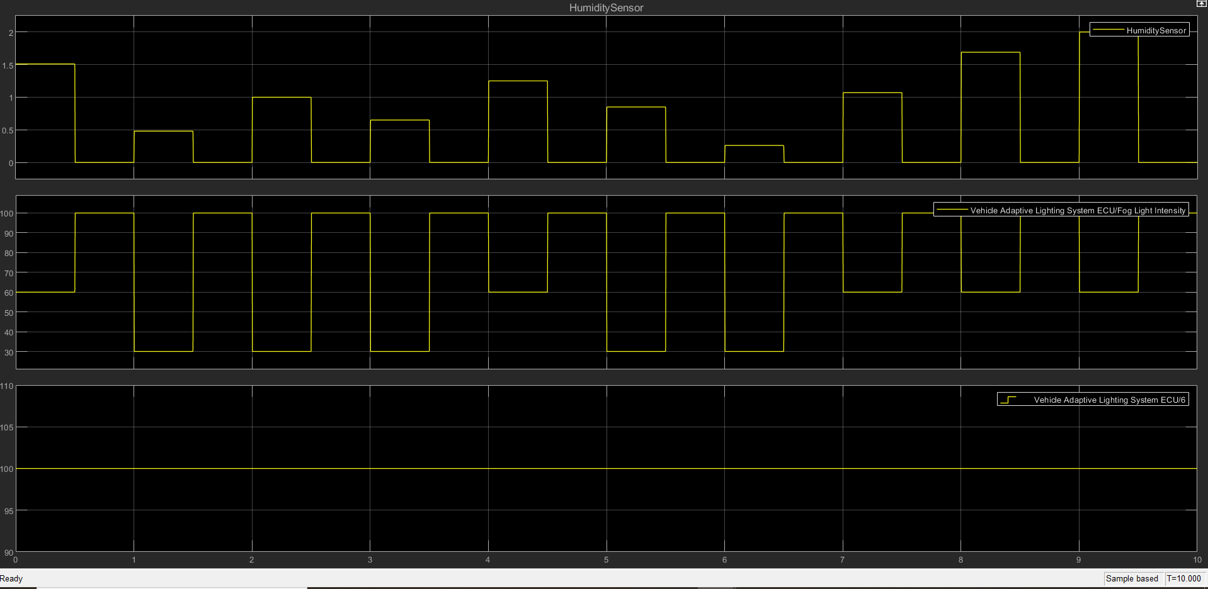

1. **Working Methodology**

## Adaptive Headlight Control system

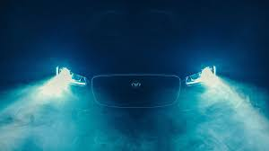

Fig. Car Headlight

High beam from the headlight causes a dangerous situation during night driving. It causes temporary blindness for the drivers that may lead to collision or sometimes it may lead to accident. Pedestrian crossing the road may get hurt. Almost 30% of accidents occurring due to headlight glare. When enough streetlights are available, there is no need of headlight beam with such high intensity. This project helps to automatically control the headlight glare in motor vehicles. Here, the headlight beam is reduced in the vehicle according to the intensity of light from the opposite vehicle.

Adaptive headlight systems are made up of several subcomponents that are monitored and controlled by an electronic control unit (ECU). It includes:

* A steering input sensor that monitors the angle of the steering wheel
* LDR Sensors to detect light present
* Ultrasonic sensor for measuring the distance of other coming vehicles in opposite direction
* small motors attached to each headlight.

Headlight direction control system turns the headlight by specified angle according to the steering position input from sensor. When steering turn in left direction headlight also turns into same direction to illuminate the road ahead, it works similarly in right direction also.

The control method for the headlight including the distance of the on-coming vehicle, illumination in the vicinity and the decision of to use high or low beam. The model is built according to the Finite State Machine theory of stateflow block and Simulink to make complex logic relationship clearer.

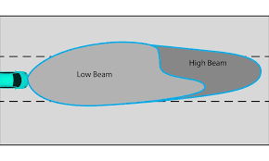

Fig. High beam and low beam pattern of headlight

Four criteria have been considered to the reference the logic for headlight control which is Distance Signal, Street Lamp Sensor signal, Front Light Reflection Sensor signal and Speed Signal. These criteria will be used to calculate the logic control of the high beam and low beam of the automatic Headlight System. The result for activating the system is related to the Distance Sensor. Assuming that a half-sinusoid source is the signal generated by the ultrasonic sensor as the distance signal. The distance transducer converts 0-50 meters to 0-5 volt.

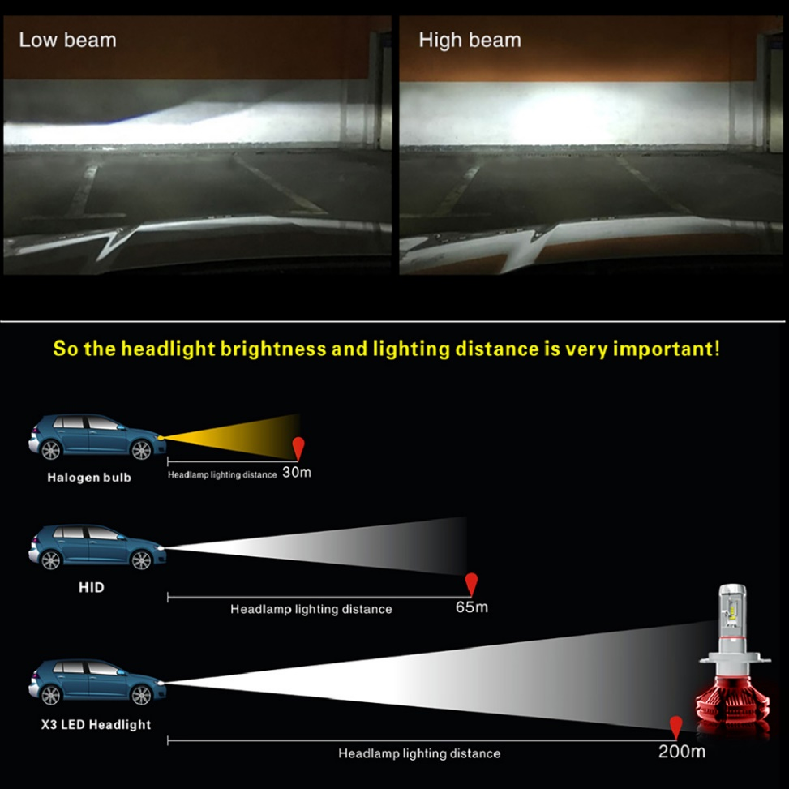

Fig. Importance of light brightness and beam control

high beam is off in the first cycle of Street lamp sensor. If an obstacle appears in 5 meters at the same cycle and the brightness is still acceptable, the low beam is on with dimming by the HID dimming control system. If an obstacle appears at a distance from 5 to 50 meters, then headlamp angle for Low Beam is adjusted according to the distance and High Beam is complete OFF. In the next cycle with the street lamp detector is in OFF state, then high beam is on because there are no obstacles detected within 50 meters. However, the high beam will be off again when an obstacle appears in 50 meters. This operation is repeating until the end of the second cycle. If the distance is in 5 meters and the brightness is over limit, low beam is also off.

## Adaptive fog light control system

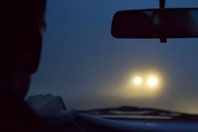 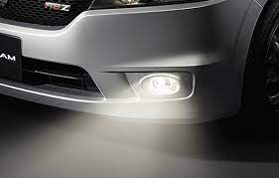

Fig. Driving in fog light Fig. Fog lights of car

Fog usually increases the chances of accidents. To reduce hazards, cars come up with fog lights. These lights are usually installed near headlights. The normal car lights refract on fog by creating a wall of light. It stops the driver to look on the road. At this time, fog lights are the best option to use. These lights remove all complications of lights in a dense fog for drivers. In order to overcome the challenges of driving in fog, system uses humidity sensor to measure the fog density present in the air and illuminate the fog light with different intensities when auto mode is selected. For low, medium and high fog density fog light illuminates with 30%, 60% and 100% intensity respectively.

## Automatic tail light control system

## 750+ Car Light Pictures [HQ] | Download Free Images on Unsplash

Fig. Tail Light of car

These are also referred to as backlights. These are the red lights at the rear of a car that light up whenever the headlights are on. Tail lights come in pairs and are helpful to make a car visible for the vehicles behind it. With the help of tail lights, you can recognize the distance between you and other cars. These lights reduce the chances to be involved with road accidents. System automatically turns on the tail lights when headlights are on and when it is required to switch on ti indicate other vehicle drivers.

**E. MATLAB and Simulink Skills Implemented**

## 1. Data Inspector

* Input signals such as Humidity sensor output, steering position data, street light, forward light, distance sensor data signals are logged for monitoring the working of system.
* Output signals such as Fog light intensity, Headlight turn angle, low beam, high beam status signals, tail light intensity signals logged for analysis of system working as per the input signal conditions.
* System simulated under various conditions and output signals between different runs are compared.

## 

## 2. MATLAB Function Block

* MATLAB function implemented for Fog light control subsystem which takes the humidity sensor data as input argument and returns the corresponding humidity level low, medium or high.
* This humidity level is given as input to another function to decide the intensity of the fog light as per fog density as 30%, 60% or 100%.

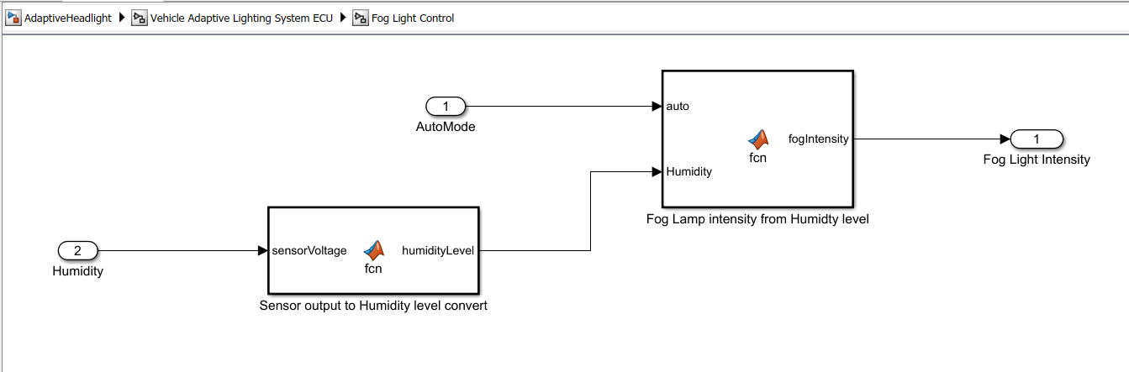

## Signal Builder

* Random signal for representing different steering positions generated using signal builders to test system for various inputs
* Light upward sensor signal generated using signal builder by modifying the square wave to check random presence of external light
* Humidity sensor output signal generated using signal builder to check system behavior for different values of humidity ranging from 0 to 3

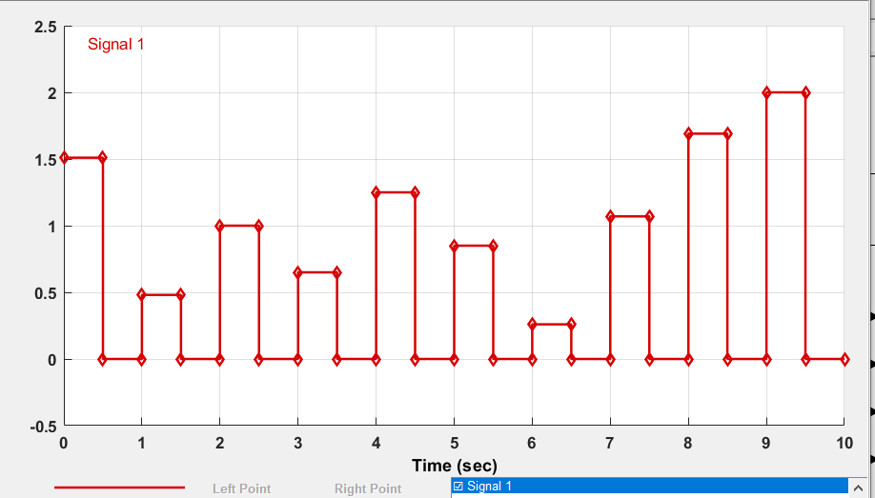

Fig. Humidity Sensor data output

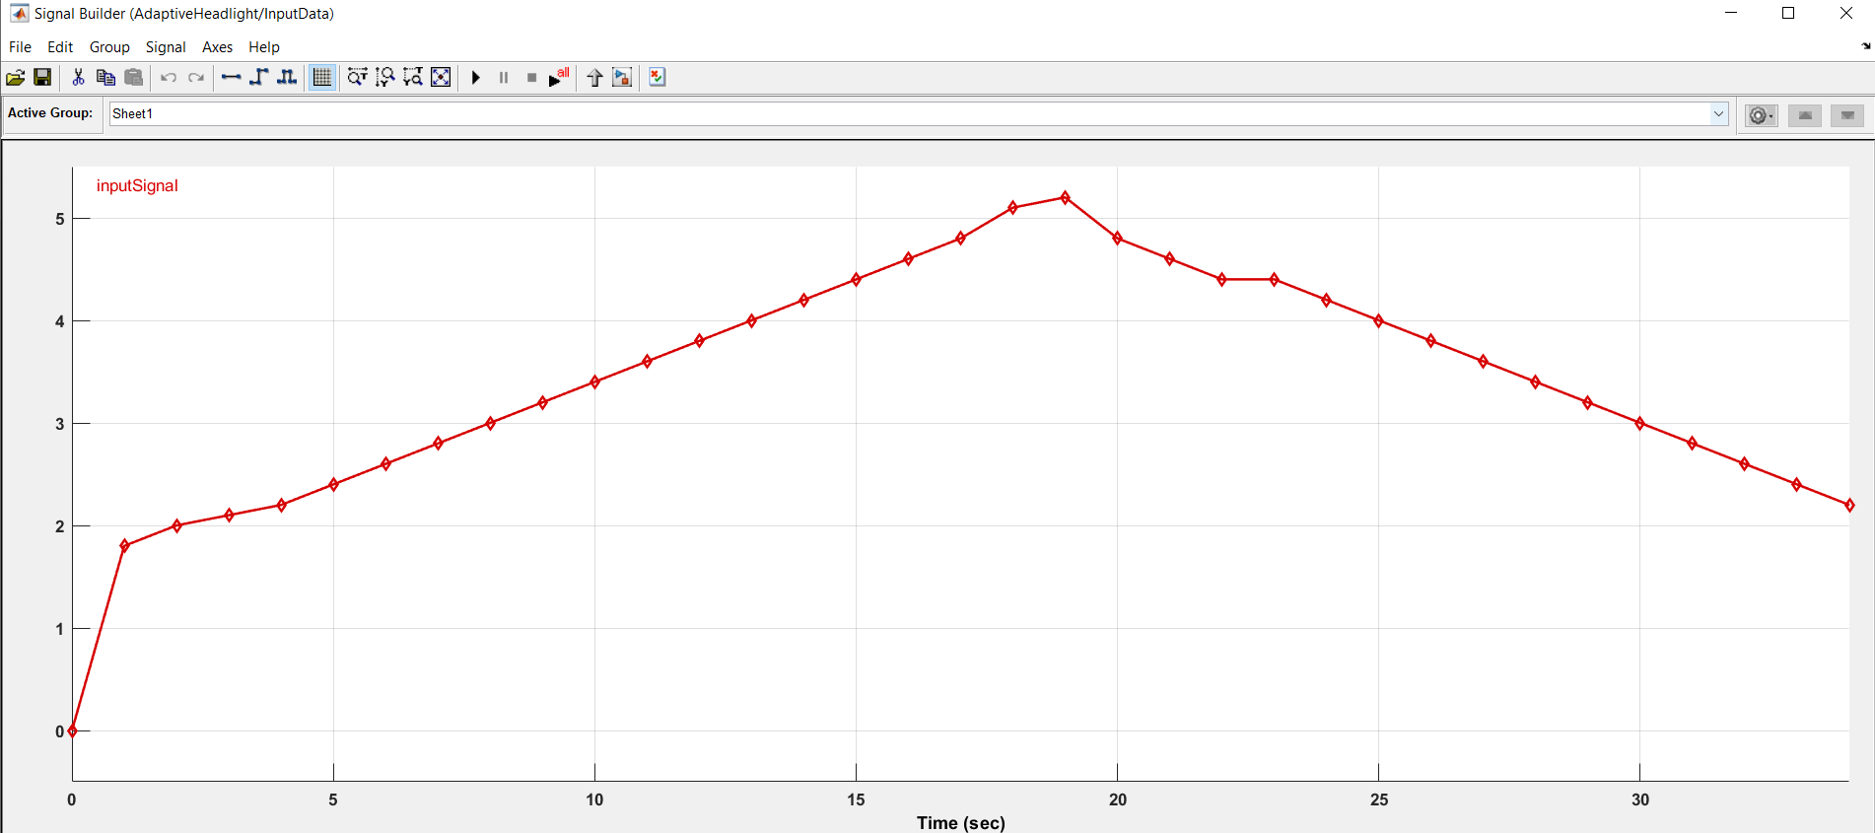

Fig. Steering Position signal

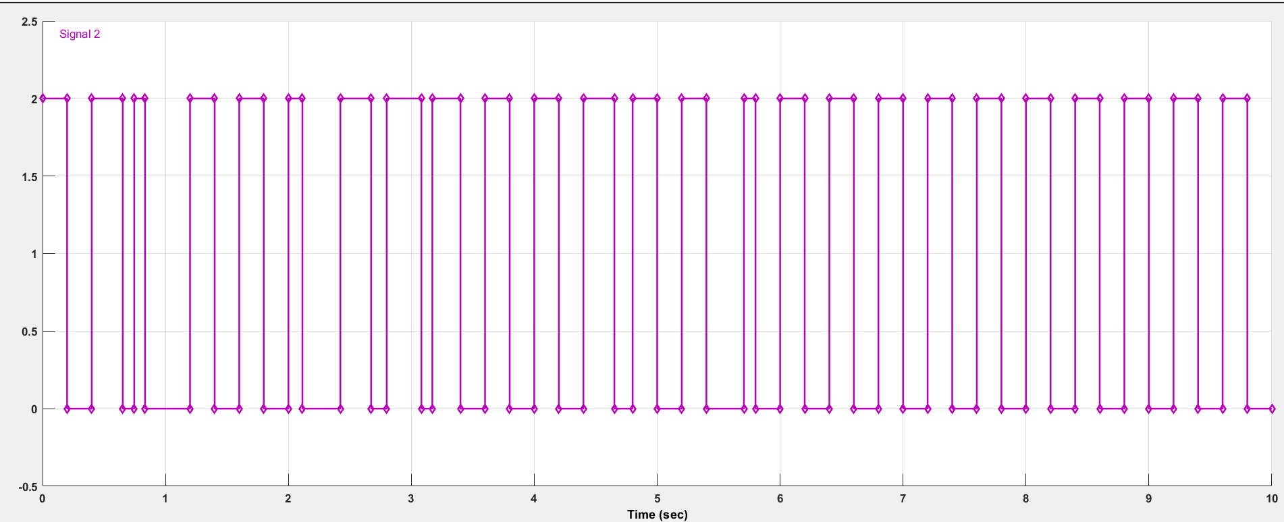

Fig. Upward light signal

## Look Up Table

* Look up table used for giving the headlight turn angle values corresponding to the steering position.
* Steering position given as breakpoint and Turning angle as Table data

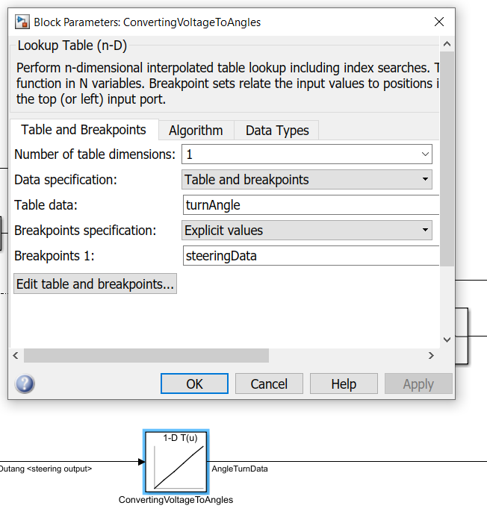

Fig. Look up table used in system

## Callbacks

* Callback functions such as PostLoadFunc used for automatic initialization of parameter values and closeFunc used for saving all files and closing the file after simulation

## Solver Strategy

* As system contains continuous states and variable auto step solver is used for adaptive lighting control system. Variable-step solvers vary the step size during the simulation. These solvers reduce the step size to increase accuracy at certain events during the simulation of the model, such as rapid state changes.
* Also, they increase the step size to avoid taking unnecessary steps when the states of a model change slowly. Computing the step size adds to the computational overhead at each step. However, it can reduce the total number of steps, and hence the simulation time required to maintain a specified level of accuracy for models with zero-crossings, rapidly changing states, and other events requiring extra computation.
* Simulation max step size selected is 0.001 to increase accuracy. Simulation performed for 10 sec.

## Data Dictionary

* Data dictionary is used for giving the default values and defined parameter values for flexibility of checking the system for different data set

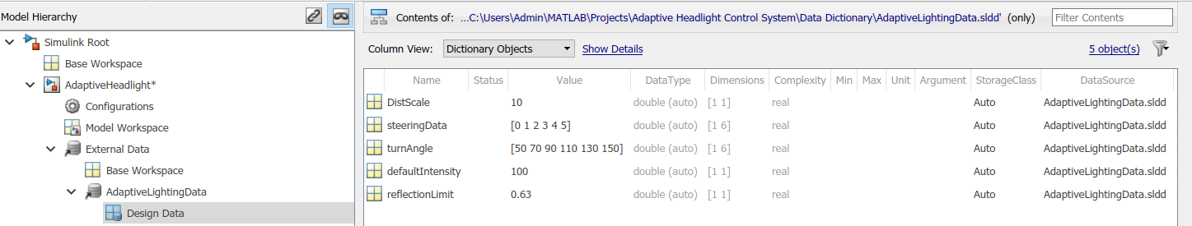

Fig. Data Dictionary

## State chart

* Statechart containing 4 states created for controlling switching of High beam and low beam depending on various sensor inputs

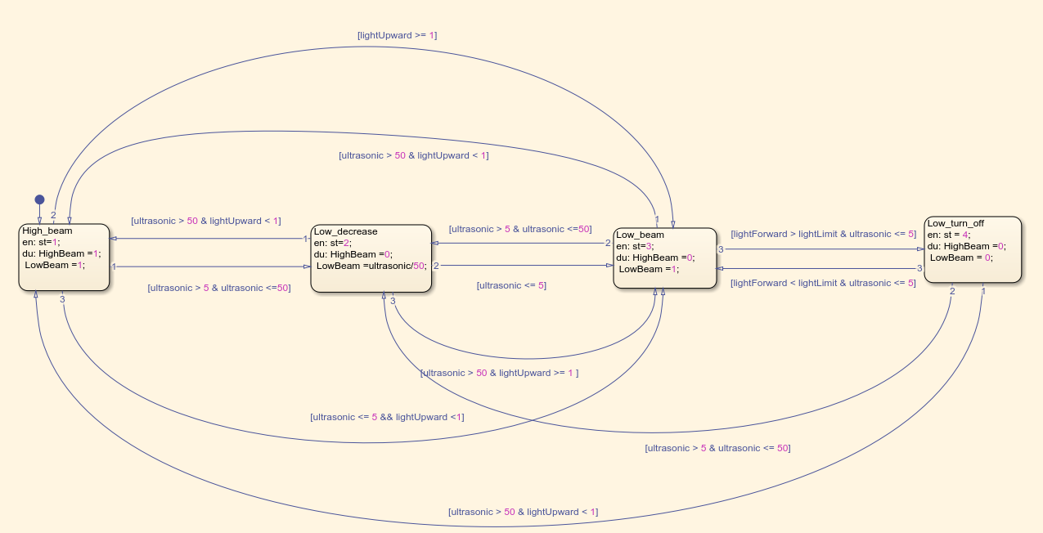

Fig. State chart Implemented

# Test plan for testing the features standalone

|  |  |  |  |
| --- | --- | --- | --- |
| Test Case | Purpose of the test case | Output | Validation |
| Manual/Auto control mode | To check whether engine of car is turned ON, Automatic control mode is selected and darkness is present by the sensor | If engine is OFF or Manual mode is selected or sufficient light is present outside then system will not start | Pass |
| Headlight direction angle control | To provide the turning angle according to the steering position | If steering is moving towards right headlights should turn to right proportional to steering.  If steering is moving towards right headlights should turn to right proportional to steering. | Pass  Pass |
| Headlight high beam and low beam control | To switch on and off the high beam and low beam of the headlight | When any vehicle is coming in opposite direction detected by ultrasonic distance sensor within 5 m distance high beam is turned off, low beam is on  When bright light is present on the road already and obstacle is close to car high beam and low beam is off.  When no obstacle present within 50m of distance from car and headlight high beam and low beam is on  When obstacle or vehicle is present between 5-50m distance high beam is off and low beam is proportional to distance | Pass  Pass  Pass |
| Fog light control | To detect the fog density and control the intensity of fog light | When fog density is low, fog light is on and illuminated with 30% intensity  When fog density is low, fog light is on and illuminated with 60% intensity  When fog density is low, fog light is on and illuminated with 100% intensity | Pass  Pass  Pass |
| Tail light control | To switch the tail lights in auto mode | When auto mode is on and headlights are on, tail lights are turned on | Pass |

# References

1. AUTOMATIC DIPPER LIGHT CONTROL FOR VEHICLES

Tejas Vijay Narkar B.E., Instrumentation Engineering, VPM’s Maharshi Parshuram College of Engineering, Maharashtra, India

1. B.Wang and X.Xiao, “Application of multi-mode control strategy in the automotive HID headlight systems” Proc. WCICA 2008.
2. T. Hacibekir, S. Karaman, E. Kural, E.S. Ozturk, M. Decmirci and B.A Guvenc, “Adaptive Headlight System Design Using Hardware-In-The-Loop Simulation”, IEEE International Conference Control Applications, 2006
3. B.P. Divakar, K.W.E. Cheng, “Study of Dimming control methods for HID automotive lamps,” International conference on Power electronics systems and applications proceedings, 2006
4. A Multi Featured Automatic Head Light Systems Prototype for Automotive Safety, International Journal of Engineering Research and Technology, Mr. Sandip S. Jadhav, Prof. Ansar A. Mulla
5. Automated Headlight Intensity Control and Obstacle Alerting System, International Journal of Engineering Research & Technology (IJERT), Arpita K , Akhila M Jain, Avi Kumar R